Technology Number -1:
Performa for Description of technology
1. | Name of Centre | : | Department of Forestry, IGKV Raipur, Chhattisgarh
2. | Name of Technology | : | Standardization of processing and value addition of Tendu fruit (Diospyrous melanoxylon Roxb.): Non timber forest products of tropical dry deciduous forest.
3. | Scientist Involved | : | Dr.R.K Prajapati, (Chandrashikha Patel Ph.D. Scholar), Dr.H.G. Sharma, Dr. Vijay Kumar
4. | Period of Technology Developed | : | Year from January 2019 to June 2021  Total 30 Months of Experiment
5. | Major benefit of technology | : | To increase the income of Tribes through processing, preservation and value addition of Tendu fruit in the form of Tendu juice a new product in the markets of India and abroad
6. | Description of technology | : | Conversation of Tendu pulp to Tendu juice
7. | Photographs | : | Attached in separate sheet
8. | Status of adoption of Technology | : | Recently developed after launching the Tendu juice in the market the assessment of adoption will be worked out
9. | Economics of Technology | : | Cost of manufacture:-  Material-  1.Tendu fruit -15 kg Cost @ of 10/- Kg  Tendu juice 360 bottles prepared from 15 kg of fruit  2. Sugar, citric acid,- 1200 Rs.  3. Packing- 1000 Rs.  Total manufacturing cost = 2350 Rs.  4.Market price of Juice bottle 200Ml @ 25/-  360 bottles X Rs. 25 = 9000/-  Cost of manufacturing juice Rs; 2300/-  Income from juice bottle Rs: 9000/-  Net Income Rs 6700/- Rs
10. | Any other details | : | After optioning patent for Government of India technology transfer to beverage industry.
11. | Organoleptic test | : | Taste and color appreciated by Governor of Chhattisgarh and instructed TRIFED to help in processing value addition and supply to market.

Tree selection at site
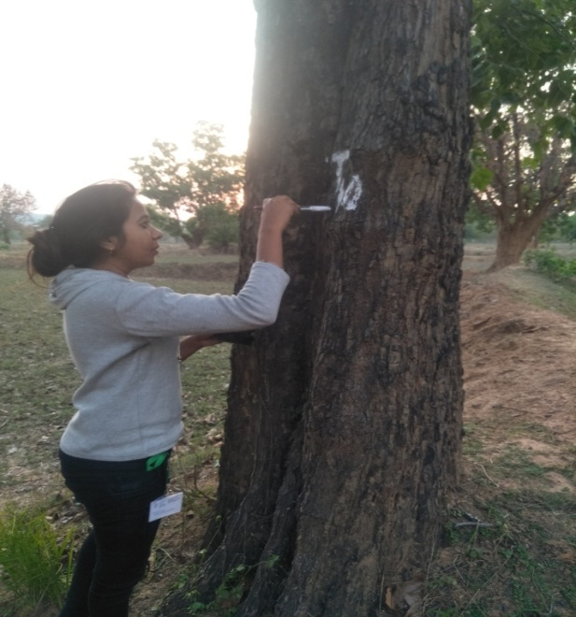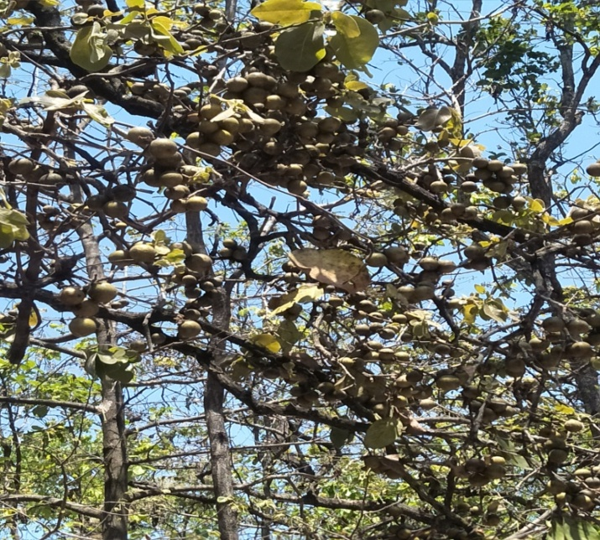
Tendu tree Diospyrous malanoxylon
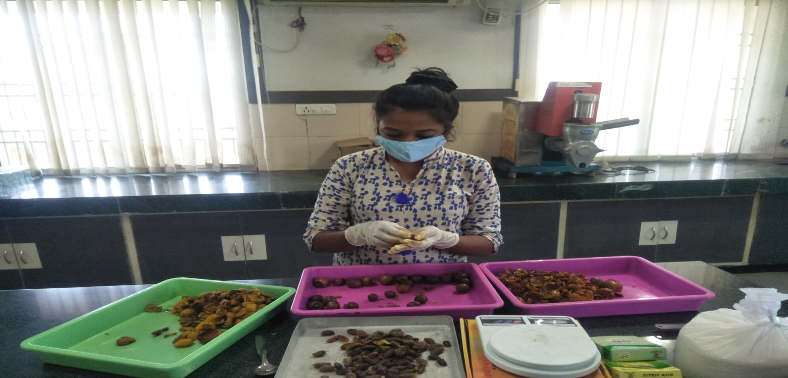
Juice Processing
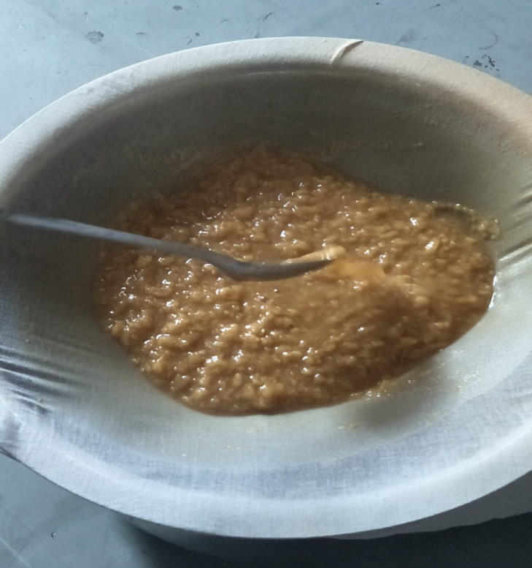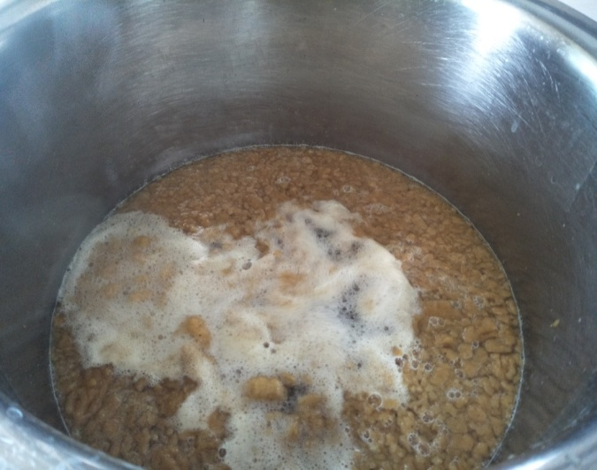
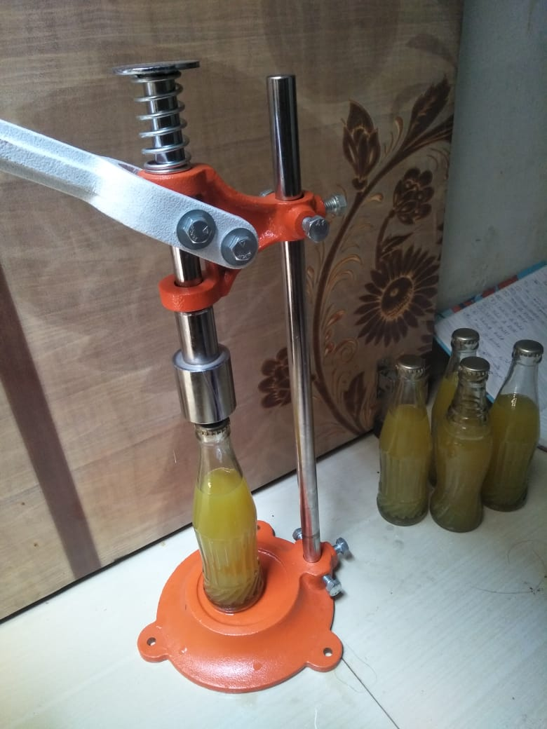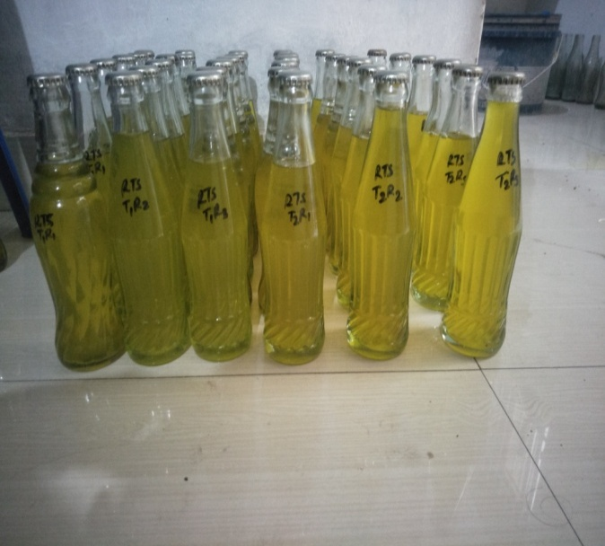
Bottle seal packing

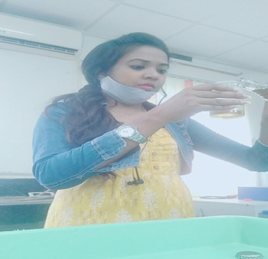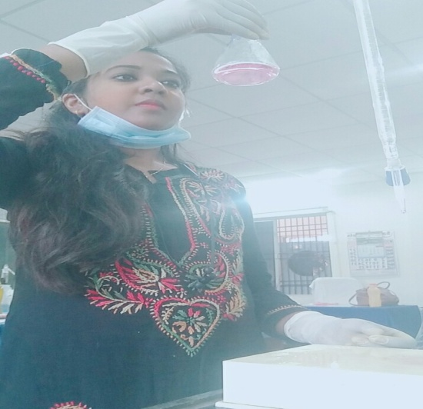
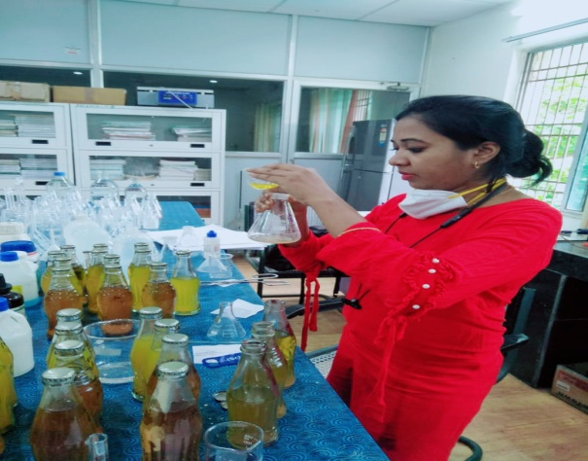
Chemical analysis

